***Hosting a Website on Amazon S3.***

**Bucket Creation:**

In AWS management console, search for S3 🡪 Create Bucket 🡪 Select the closest region 🡪 provide S3 bucket name.

** (An S3 bucket name is globally unique, and all AWS accounts share the namespace. After you’ve created the bucket, no other AWS account in the world can use the same bucket name unless we delete the bucket)

Object Ownership: ACLs enabled. (Access Control Lists) 🡪 Bucket Owner: Preferred

** An ACL = it is a set of rules that decides who get access to a resource. With ACLs, different AWS accounts can own and control different files in your bucket.

Public access can be granted to buckets using ACLs. Uncheck the box ‘Block public access for all’. (Yellow Warning)

** (Public access to buckets is blocked by default. Because the files in my static website will need to be accessed through the internet, I’ve permitted the public access)

Bucket Versioning: Enable (Once it’s turned on, we can’t turn it off)

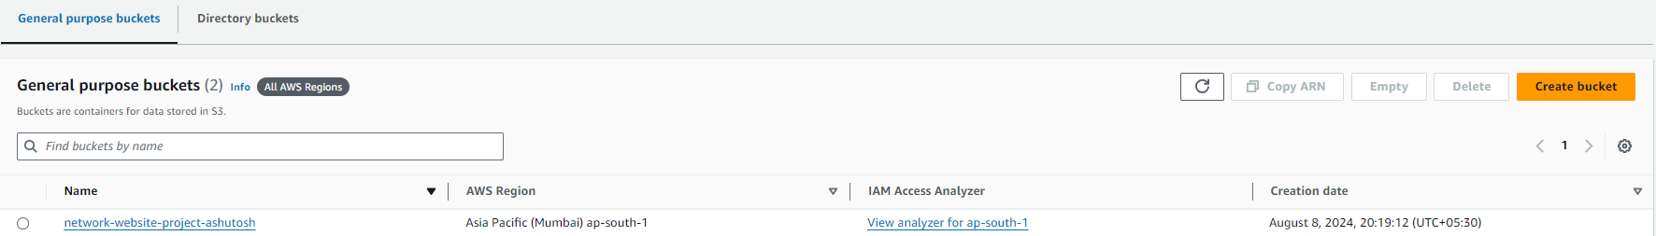

Select the newly created bucket, upload the Static Website files in the bucket.

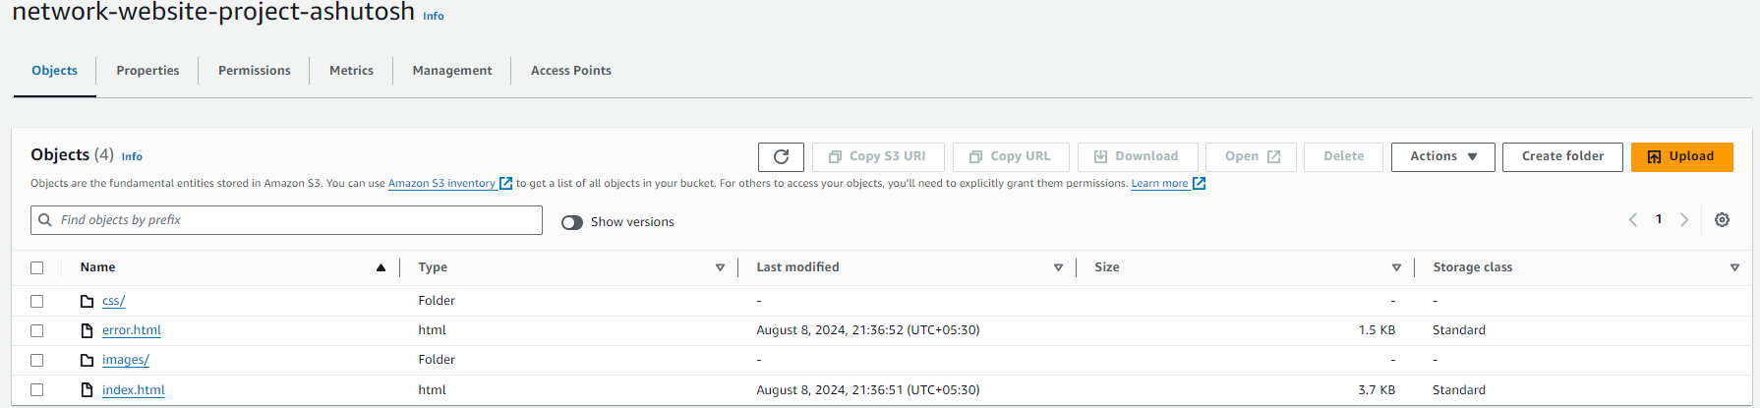

** Website hosting means making our website public on the internet. Website hosting = storing HTML file on webserver, so it’s accessible online.

By configuring the S3 bucket for hosting, we’re telling this bucket: “please create a URL that will take anyone to a page that displays the HTML file I just uploaded”

**Configure the bucket for hosting:**

Select the bucket 🡪 Go to Properties 🡪 At bottom, statis website hosting – by default is disabled, enable it.

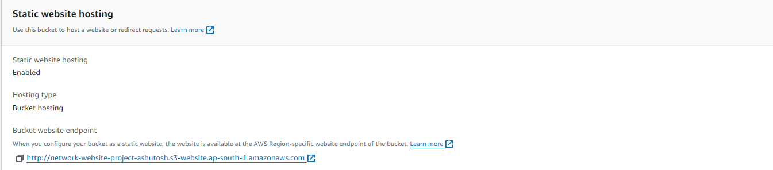

Open the newly generated URL in a new tab, it’ll result in an error – this is because the S3 files are still private.

** Objects are **PRIVATE** by default**.**

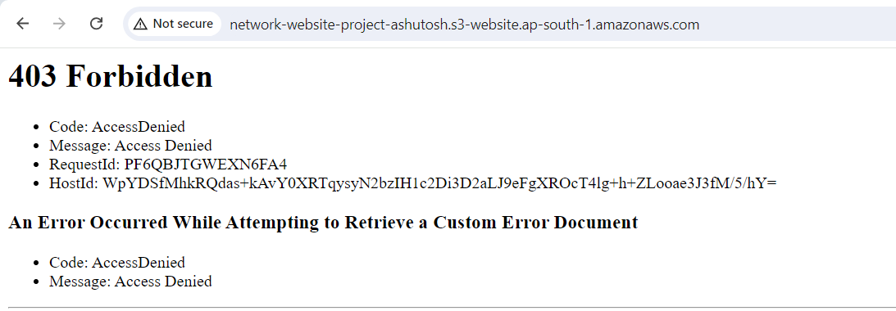

This error tells me that the S3 is hosting a static website but the S3 files are private and not accessible publicly.

** To solve this error, we need to make the files/objects in a bucket to public – this is why we enabled ACLs while creating the bucket.

Go to S3 – Objects 🡪 Select all files and folders of website 🡪 Actions 🡪 Make public using ACLs.

**Output on website:**

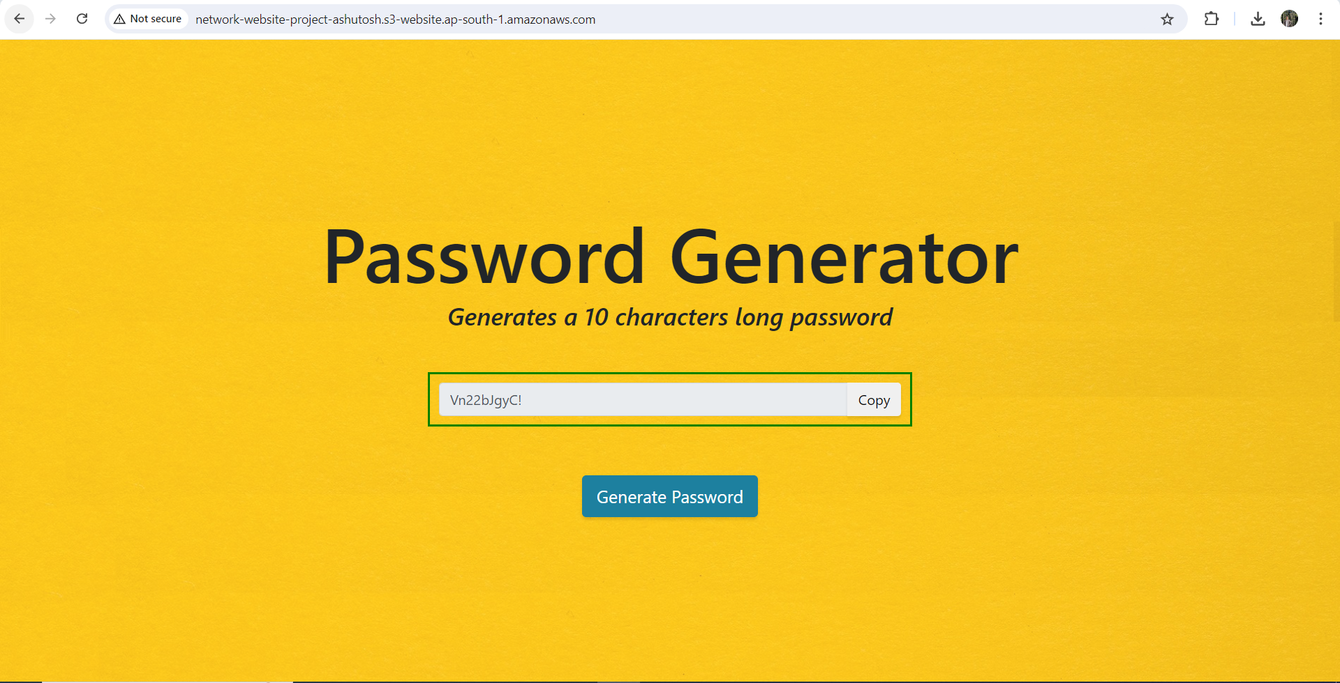

I’ve successfully hosted a static website using Amazon S3.

After this, I’ve deleted the resources to avoid getting charged.